**NAME OF EVENT (Site Plan, Noise Plan, Risk Register)**

Date/Time/Location:

**Site Plan**

**General Information List**

| Toilets | *1 Male, 1 Female, 1 Unisex (Disabled Accessible)* |
| --- | --- |
| Marquees | *3 (3x3 meters) - see site map for location* |
| Food Vendors | *1 N. Entrance (small), 1 S. Entrance (full size)* |
| Speakers | *2 at each stage, 6 Total (east and west facing)* |
| Emergency Exits/ Emergency vehicle access | *At N. Entrance 3mtr wide, at S. Entrance 2.5 mtr wide* |
| Trash Receptacles | *6, 240L (3 rubbish, 3 recycling)* |
| Generators/Electrical Cables | *Please refer to the risk register* |

**EXAMPLE SITE PLAN BELOW**

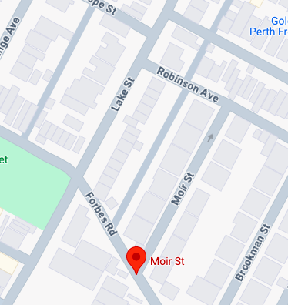

**Emergency Muster Point 1**

**Corner of Robinson Ave and Lake St.**

**Emergency Muster Point 2**

**Corner of Forbes Rd and Lake Street (Stuart Street Reserve)**

**Site Map Key**

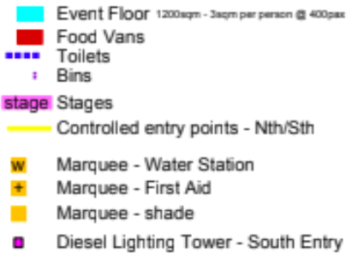

**Emergency vehicle entrance**

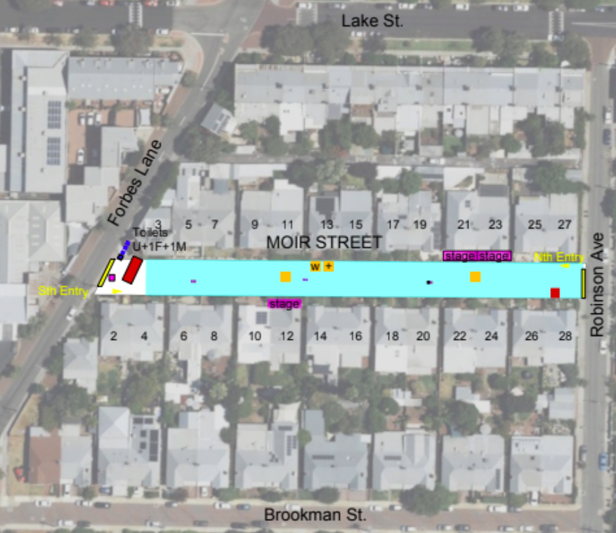

**NOISE MANAGEMENT PLAN/ EXAMPLE TEMPLATE**

Event Name:

Date:

Risk Owner: *name and phone of people in group (can be the leader of the committee)*

1. Event date, start and finish times and venue (street/park name if open ait):

2. Include a diagram / sketch and details of ~~stage~~ and speaker location.

There is no stage, the musicians will be playing on resident porches.

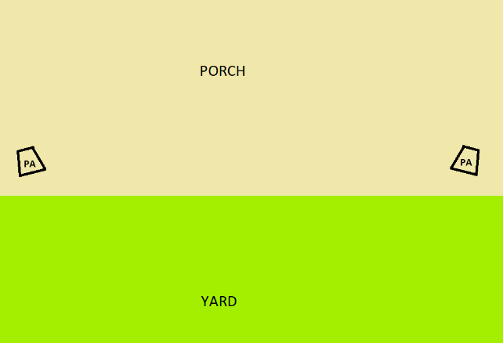

3. Provide proposed timings for emission of sound including.

Music will commence at 4pm and end at 8pm (10 different artists playing).

4. Detail how compliance and sound levels will be monitored during the event.

A CCA sound technician will be on site, at the 3 Porches they have supplied equipment for, for the duration of the event. The sound technician will be monitoring sound levels of their PA for the duration to minimise impact to neighbouring properties.

5. Detail how the affected surrounding community will be notified of the event.

All residents have been approached 'in person' and a letter drop was completed one month ago (the letter is provided in the Gfolder in communications). Another letter drop with the 'day of' the phone number will be completed a week out from the event, which was detailed in the first letter. (Moir St, Robinson St., Brookman St.)

6. Detail the complaint management procedures to be implemented:

See above, this was detailed in the letter to the residents and the phone will be manned by the Secretary and Event Marshall for the totality of the event.

7. Detail the management methods that will be used to reduce noise impact on the surrounding community.

Speakers will be placed in a way to direct sound into the yard in front of the porch and minimise spill to neighbouring properties. Cardioid subwoofers will be utilised to minimise bass frequencies. Anticipated SPL levels of 92 dB at the footpath in front of each porch. CCA sound technicians will comply with any/all directions to turn down.

|  | **Risk Register (Examples/Template)** | | | | |  |
| --- | --- | --- | --- | --- | --- | --- |
|
| **Date/Time/Location:** | | | | |
|  |  |  |  |  |  |
|  | ID | Description of Risk | Risk Response | Risk Level | Risk owner | Notes |
|  | 1 | **Injury** | Police and emergency services have been notified of the event and TMP has been provided to police. We will have a first aide kit on hand at the event as well as three volunteers with first aide training. Egress and ingress for emergency vehicles has been assured on the site plan | LOW | *Name and phone number of volunteer responsible* |  |
|  | 2 | **Traffic Control** | Refer to the Traffic Management Plan. This is a low traffic residential area and all residents have been informed of the closure and offered alternate parking for the day. In addition, volunteers will be on hand to assist any residents with parking. | LOW | *Name and phone number of volunteer responsible* |  |
|  | 3 | **Crowd Control** | The event will have 2 entry points on both the south and north side of Moir Street. Two volunteers will be at the entrance for the first 2 hours of the event. Tickets will be scanned to ensure participants have been ticketed and to ensure no one entering the event is unfit to do so. Synced e-tickets will be used to monitor the event. Reentry is one-in-one-out when capacity is reached. | Medium | *Name and phone number of volunteer responsible* |  |
|  | 4 | **Hydration** | There will be a water station available at the event free of charge. | Medium | *Name and phone number of volunteer responsible* |  |
|  | 5 | **Electrical** | Generally there is no electricity on the main fairway, only at private residences with no public access. The Main food van on the south will have its own power. A small sweet vendor will be located at the front of residence 28 sourcing power from inside. A diesel lighting tower is located at the southern entry adjacent to the toilets and food van to provide additional lighting in this area.~AV Company -- no electrical on the may fairway, only at private residences with no public access. | Low | *Name and phone number of volunteer responsible* |  |
|  | 5 | **Lighting** | The event will take place partly in the dark hours. The existing street lighting is all functioning and provides adequate lighting for safe general movement across the event space. A diesel lighting tower is located at the southern entry adjacent the toilets and food van to provide additional lighting in this area. Additional event lighting will be placed at stage locations and the northern entrance. the AV company will be lighting the performance areas, and LED cube lighting (doubles as seating) will be placed throughout the street. Festooned lighting throughout. | Medium after dark | *Name and phone number of volunteer responsible* |  |
|  | 6 | **Accessibility** | The event is fully accessible for those with physical disabilities. Existing pedestrian pathways will be utilised for both site entries. At least one pedestrian pathway (east or west) will be kept clear along any section along the full length of the street. Driveway crossovers will be utilised to enable transitions from east to west. An accessible toilet will be at the event. | Low | *Name and phone number of volunteer responsible* |  |