Let this be the last time you scrabble about to look for the incorporation certificate when you need your ABN. The last time you look up your social media link or try and remember what hashtags to use.
Do it 1 MORE TIME, fill it in below, then it’s done
CONTACT DETAILS
Organisation Name
ABN
(if applicable)
TFN
(if applicable)
Email
Website
(if applicable)
Facebook link
Account Name
Facebook
Instagram link
Account Name Instagram
Standard hashtags  Can be copied and pasted | Delete these and or add your own  #community #positivity #yourorganisationname #YourLocalLGA #visitnortham #arts #wheatbelt #CommunityMatters  #LocalConnections #StrongerTogether #CommunityEvents  #BuildingCommunity #SupportLocal #TogetherWeThrive  #CommunityImpact #MakingADifference #LocalLove  #BetterTogether #LocalEngagement #BeTheChange
Any regular organisational tags you might use  Can be copied and pasted as needed | Add your own  @townteammovement  @ShireofX  @Lotterywest

BANK ACCOUNT
Bank and  Account type  (Saver, Debit card etc) | Account Name | BSB | Account Number

25-WORD INTRODUCTION OF YOUR GROUP
Don’t be shy in using ChatGBT for example to start you off and edit to give a personal touch.E.g.
The X community group is for those interested in X and where people come together to do Y

50-WORD INTRODUCTION OF YOUR GROUP
E.g.
Our community group is a welcoming space for individuals to …
We focus on A, support B, and create C.
Whether through events, discussions, or volunteer efforts, we aim to D

POTENTIAL REFEREES
Contact these referees prior and ask if you can list them on funding applications. Record their details here and let them know when you use them.

Name | Position | Organisation | Email | Phone Number

PAST PROJECTS
Combat success amnesia - Every time you finish an activity, list it here. A craft destash, a community weekly walk, collaboration meeting
Project / Activity name | Date of activity | Numbers / Demographics | Successes / Highlights  (dot points) | Google Drive link
Try to make every activity name unique perhaps use the year  Eg Crafty catchup May2024 |  | Eg  15 women in the 50-64 bracket | - Social connection  - Learning new skills  - New partnership / collaboration | If you get into the habit of setting up your Google drive with folders called project X you can easily paste the link here to go direct to the folder

SUPPORT LETTERS
List the contact details of people /organisations that have indicated they will consider providing a letter of support (depending on the specific activity you require support for). Consider these suggestions:
- Road safety initiative / security – Local police station
- Child friendly initiative – local playgroup, school PnC
- Community activity / initiative -Local government association, local chamber of commerce etc

Contact Name | Position | Organisation | Email

Use ChatGBT to create a draft supporting letter BUT (as with ALL AI) use what AI provides as a first draft and edit it to match your needs. Don’t make false claims or fail to check the content.

EXAMPLE SUPPORTING LETTERS

Letterhead

Local Shire / Town of
Chamber of Commerce /
Dear [Funding Authority name],

On behalf of the [Chamber of Commerce/Local Government Association/Community Group], I am writing to express our strong support for the (insert initiative name here) proposed by (insert your community group name here).
.
Economic development
We believe that supporting this initiative aligns with both our objectives and the goals of the (funding authority name) in fostering economic development and supporting small businesses.

Mental Health
We believe that supporting this initiative aligns with both our objectives and the goals of the (funding authority name) in raising awareness of mental health issues.

Recycling Initiatives
We believe that supporting this initiative aligns with both our objectives and the goals of the (funding authority name) in promoting sustainability, reducing waste, and fostering a community-wide commitment to environmental responsibility through increased awareness and active participation in recycling efforts.

We strongly encourage your consideration of this funding request and look forward to seeing the positive outcomes for our community. Thank you for your time and support.
Sincerely,
Name
Position
Organisation
[Contact Information]

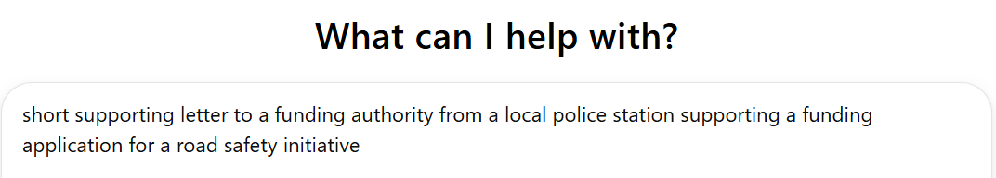
Letterhead

Dear [Funding Authority Name],

Subject: Support for Road Safety Initiative Funding Application

I am writing to offer the full support of [Police Station Name] for the funding application submitted by [Applicant/Organization Name] for the road safety initiative (insert safety initiative here).

As a local law enforcement agency, we are committed to enhancing the safety and wellbeing of our community, and we believe this project will significantly contribute to reducing road accidents and promoting safer driving practices. The proposed initiative aligns with our goals to address key safety issues in the area, particularly concerning high-risk zones and vulnerable road users. We have seen firsthand the impact that effective safety programs can have in reducing traffic-related incidents, and we are confident that this project will yield positive outcomes for the community.

We fully support this application and encourage the funding authority to consider the long-term benefits of supporting this critical initiative.

Thank you for your consideration.

Sincerely

Name
Position
Date

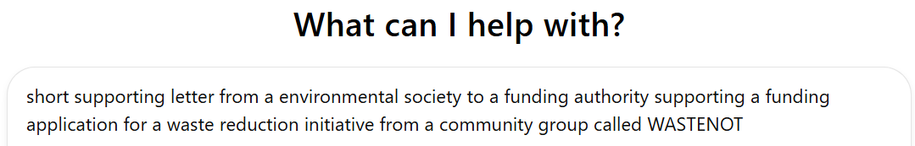
Letterhead

Dear [Funding Authority's Name],

Re : Support for WASTENOT’s Waste Reduction Initiative

I am writing on behalf of [Environmental Society's Name] to express our strong support for the funding application from WASTENOT.

We have been following WASTENOT’s impactful efforts in waste reduction and environmental awareness, and we are confident that their proposed initiative will significantly contribute to tackling waste management issues at the grassroots level. Their approach aligns with our shared mission to promote sustainable practices, reduce environmental footprints, and encourage community engagement in addressing climate change.

The project has a clear, well-thought-out strategy, and the leadership team has demonstrated consistent dedication and success in similar efforts.

We wholeheartedly endorse this initiative and believe that, with the support of your funding, WASTENOT will be able to expand its reach and achieve even greater environmental and community impacts. We urge you to consider this application favorably, as it is a vital step toward a more sustainable and responsible future for our community.

Thank you for your time and consideration.
Sincerely,
Name, Position, Date

